2013

Edison
Housing Authority Budget

FIB ME
Community
Affairs
APR 1 8 2013
DIVISION OF
LOCAL GOVERNMENT SERVICE

Division Of Local Government Services

2013
PAGE 1
EDISON
HOUSING AUTHORITY BUDGET
FROM: JULY 1, 2013 TO JUNE 30, 2014
For Division Use Only
CERTIFICATION OF APPROVED BUDGET
It is hereby certified that the approved Budget made a part hereof complies with the requirements of law and the rules and regulations of the Local Finance Board, and approval is given pursuant to N.J.S.A. 40A:5A-11.
State of New Jersey
Department of Community Affairs
Director of the Division of Local Government Services
By: | /4.4f
Date: | i 7// h ³

CERTIFICATION OF ADOPTED BUDGET
It is hereby certified that the adopted Budget made a part hereof has been compared with the approved Budget previously certified by the Division, and any amendments made thereto. This adopted Budget is certified with respect to such amendments and comparisons only.
State of New Jersey
Department of Community Affairs
Director of the Division of Local Government Services
By:
Date:

PREPARER'S CERTIFICATION
PAGE la
of the
2013
EDISON
HOUSING AUTHORITY BUDGET
FROM: JULY 1, 2013 TO JUNE 30, 2014
It is hereby certified that the Housing Authority Budget, including both the Annual Budget and the Capital Budget/Program annexed hereto, represents the members of the governing body's resolve with respect to statute in that; all estimates of revenue are reasonable, accurate and correctly stated, all items of appropriation are properly set forth and in itemization, form and content, the budget will permit the exercise of the comptroller function within the Authority.
It is further certified that all proposed budgeted amounts and totals are correct. Also, I hereby provide reasonable assurance that all assertions contained herein are accurate and all Supplemental Schedules required are completed and attached.
Preparer's Signature: | _{(A,s&-)4.7_,„-}  f
 | ^{1'4}Name: Anthonylolcari, CPA
Title: | Fee Accountant
Address: | 2035 Hamburg Turnpike Unit H Wayne, NJ 07470
Phone Number: | (973)831-6969 | Fax Number: | (973)831-6972
E-mail address | tony@polcarico.com

APPROVAL CERTIFICATION
PAGE lb
of the
2013
EDISON
HOUSING AUTHORITY BUDGET
FISCAL YEAR: FROM JULY 1, 2013 TO: JUNE 30, 2014
It is hereby certified that the Housing Authority Budget, including Supplemental Schedules appended hereto, are a true copy of the Annual Budget and Capital Budget/Program approved by resolution by the Members of the Edison Housing Authority, at an open public meeting held pursuant to N.J.A.C. 5:31-2.3, on the day of April 9, 2013.
It is further certified that the recorded vote appearing in the resolution represents not less than a majority of the full membership of the governing body thereof.
Secretary's Signature: | Yi2a-e5KG4e-,--re--) (:„1/4.__L
Name: | Madeline Cook, PHM
Title: | Executive Director
Address: | 14 Rev. Samuel Carpenter Boulevard Edison, NJ 08820
Phone Number: | (908)561-2525 | Fax Number: | (908)561-7517
E-mail address | Mcook@edisonha,org

HOUSING AUTHORITY INFORMATION SHEET
Page lc
2013
Please complete the following information regarding this Housing Authority:
Name of Authority: | Housing Authority of the Township of Edison
Address: | 14 Rev. Samuel Carpenter Boulevard
City, State, Zip: | Edison | NJ 08820
Phone: (ext.) | (908)561-2525 Fax: | (908)561-7517

Preparer's Name: | Anthony G. Polcari, CPA Fee Accountant
Preparer's Address: | 2035 Hamburg Turnpike Unit H
City, State, Zip: | Wayne | NJ 07470
Phone: (ext.) | (973)831-6969 Fax: | (973)831-6972
E-mail: | tony@polcarico.corn

Chief Executive Officer: Madeline Cook
Phone: (ext.) | (908)561-2525 | Fax: | (908)561-7517
E-mail: | Mcook®edisonha,org

Chief Financial Officer:
Phone: (ext.) Fax:
E-mail:

Name of Auditor: | Anthony Giampaolo, CPA
Name of Firm: | Hymanson, Parnes & Giampaolo
Address: | 467 Lincroft-Middletown Road
City, State, Zip: | Lincroft | NJ 07738
Phone: (ext.) | (732)842-4550 Fax: | (732)842-4551
E-mail: | hpgcpa@comcast.net

Membership of Board of Commissioners (Full Name) | Title
Carlos N. Sanchez | Chairperson
Walter Szoludko | Vice-Chairperson
Kathryn Neal | Chairperson
Frank Mistretta | Chairperson
Raymond Koperwats | Chairperson
Barry Telesnick | Chairperson

2013
PAGE 2
EDISON
HOUSING AUTHORITY BUDGET RESOLUTION
FISCAL YEAR: FROM JULY 1, 2013 TO JUNE 30, 2014
WHFREAS, the Annual Budget and Capital Budget for the Edison Housing Authority for the fiscal year beginning July 1, 2013 and ending June 30, 2014 has been presented before the Members of the
Housing Authority at its open public meeting of April 9, 2013 and
WHEREAS, the Annual Budget as introduced reflects Total Revenues of $5,670,194, Total Appropriations, including any Accumulated Deficit if any, of $5.661.694 and Total Fund Balance utilized of $-S) and
WHEREAS, the Capital Budget as introduced reflects Total Capital Appropriations of $103,000 and Total Fund Balance planned to be utilized as funding thereof; of $-0--* and
WHEREAS, the schedule of rents, fees and other user charges in effect will produce sufficient revenues, together with all other anticipated revenues to satisfy all obligations to the holders of bonds of the Authority, to meet operating expenses, capital outlays, debt service requirements, and to provide for such reserves, all as may be required by law, regulation or terms of contracts and agreements; and
WHEREAS, the Capital Budget/Program, pursuant to N,J.A.C, 5:31-2, does not confer any authorization to raise or expend funds; rather it is a document to be used as part of the said Authority's planning and management objectives. Specific authorization to expend funds for the purposes described in this section of the budget, must be granted elsewhere; by bond resolution, by a project financing agreement, by resolution appropriating funds from the Renewal and Replacement Reserve or other means provided by law.
NOW, LHEREFORE BE rr RESOLVED, by the Members of the Edison Housing Authority, at an open public meeting held on April 9, 2013 that the Annual Budget, including appended Supplemental Schedules, and the Capital Budget/Program of the Edison Housing Authority for the fiscal year beginning July 1, 2013 and ending June 30, 2014, is hereby approved; and
BE IT FURTHER RESOLVED, that the anticipated revenues as reflected in the Annual Budget are of sufficient amount to meet all proposed expenditures/expenses and all covenants, terms and provisions as stipulated in the said Housing Authority's outstanding debt obligations, capital lease arrangements, service contracts, and other pledged agreements; and
BE IT FURTHER RESOLVED, that the governing body of ihe Edison Housing Authority will consider the 4nnual Budget and Capital Budget/Program for adoption or September 10 , 2 013
e^{,2}t/:44,e,ei
_ April 1 1 , 2013
(date)
(Secretary's signature)

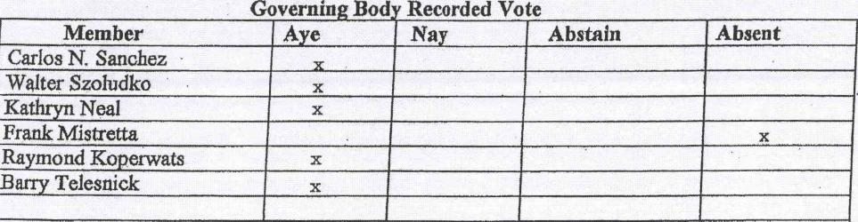
Absent
Member
Carlos N. Sanchez Walter Szoludko
Kathryn Neal
Frank Mistretta
Raymond Koperwats
BatTy Telesnick
Aye I Nay Abstain
x
Governing.Bod
Recorded Vote
x
x

2013
EDISON
HOUSING AUTHORITY BUDGET
FISCAL YEAR: FROM JULY 1, 2013 TO JUNE 30, 2014
BUDGET MESSAGE
- Complete a brief statement on the 2013 proposed Annual Budget and make comparison to the current year's adopted budget. Explain significant increases or decreases, if any.
The Edison Housing Authority's annual budget is prepared in compliance with HUD's Asset Management and Project-Based Accounting and Reporting requirements. The 2013 operating budget provides for each cost center under the asset management model will operate at a positive cash flow. Revenues and expenses for the 2013 fiscal year are consistent with actual operating results for 2011 and 2012 adjusted for the reduced level of funding and subsidies to be received from HUD. Operating expenses have been appropriately reduced based on the projected decrease in HUD subsidies.
- Complete a brief statement on the impact the proposed Annual Budget will have on Anticipated Revenues, especially service charges and on the general purpose/component unit financial statements. Explain significant increases or decreases, if any.
Each property will be funded separately by HUD and the Central Office Cost Center will operate on management fees received from the Authority's operating cost centers. Charges are based on allowable amounts as published by HUD.
- Describe the state of the local/regional economy and how it may impact the proposed Annual Budget, including the planned Capital Budget/Program.
The PHA does not receive any state, county or local financing. However, changes in the economy may affect the income of public housing tenants, which in turn affects the amount of rents collected by the Authority.
- Describe the reasons for utilizing Fund Balance in the proposed Annual Budget, i.e. rate stabilization, debt service reduction, to balance the budget, etc.
N/A — the Authority will not utilize any fund balance in 2013 or 2012.
- If the proposed Annual Budget contains an Accumulated Deficit either existing or anticipated, pursuant to N.J.S. 40A:5A-12, then an explanation as to reasons for occurrence must be disclosed.
N/A — no accumulated deficits exist.
- Is the Authority required to implement project based budgeting and asset management under H.U.D. rules and regulations? If yes, has the Authority Board of Commissioners adopted a Project-based budget?
Yes. The Board of Commissioners has prepared a project-based budget as required by HUD's asset management regulations.
PAGE 3

2013
HOUSING AUTHORITY BUDGET
Housing Authority of the Township of Edison Housing Authority July 1, 2013 to June 30, 2014
---ANTICIPATED REVENUES---

2012
2013 CURRENT YEAR'S
CROSS PROPOSED ADOPTED
REF. BUDGET BUDGET
OPERATING REVENUES
* A-1 $5,937,385 *
TOTAL RENTAL FEES
* A-2
OTHER OPERATING REVENUES
TOTAL OPERATING REVENUES
NON-OPERATING REVENUES
*
* * * *
R-1 *
*
2012
2013 CURRENT YEAR'S
CROSS PROPOSED ADOPTED
REF. BUDGET BUDGET

OPERATING GRANTS & ENTITLEMENTS A-3 *
LOCAL SUBSIDIES & DONATIONS A-4 *
INTEREST ON INVESTMENTS A-5
$18,600
OTHER NON-OPERATING REVENUES A-6 *
*
$17,000

TOTAL NON-OPERATING REVENUES R-2 * $838;792
TOTAL ANTICIPATED REVENUES  (R-1 + R-2) | * | R-3 *

.5;6

PAGE 4

2013
HOUSING AUTHORITY BUDGET
Housing Authority of the Township of Edison Housing Authority
July 1, 2013 to June 30, 2014
---BUDGETED APPROPRIATIONS--
--NON-OPERATING APPROPRIATIONS--
2012
2013 CURRENT YEAR'S
CROSS PROPOSED ADOPTED
REF. BUDGET BUDGET
... , . .....
NET INTEREST DEBT PAYMENTS RETAINED EARNINGS  RETAINED EARNINGS - SECT 8  OTHER NON-OPERATING APPROPRIATIONS OTHER (SECT. 8 / HOUSING VOUCHER) | D-2  C-1  C-2  C-3  C-4 * |  |  |  | *  *
TOTAL NON-OPERATING
APPROPRIATIONS E-4
(D-2+C-1+C-2+C-3-I-C-4)
ACCUMULATED DEFICIT * E-5 * * *
TOTAL OPERATING & NON-OPERATING
APPROPRIATIONS & ACCUMULATED DEFICIT (E-3+E-4+E-5)
E-6 *
........

LESS : RETAINED EARNINGS UTILIZED
TO BALANCE BUDGET R-4 * *

TOTAL APPROPRIATIONS AND RETAINED EARNINGS (E-6 - R-4)
E-7 * 5

PAGE 6

2013
EDISON
HOUSING
AUTHORITY
CAPITAL
BUDGET/
PROGRAM

CERTIFICATION
of the
Page CB-1
2013
EDISON
HOUSING AUTHORITY CAPITAL BUDGET/PROGRAM
FISCAL YEAR: FROM JULY 1, 2013 TO JUNE 30, 2014
fX 1 It is hereby certified that the Authority Capital Budget/Program annexed hereto is a true
copy of the Capital Budget/Program approved, pursuant to N.I.A.C. 5:31-2.2, along with the Annual Budget, by the Members of the Edison Housing Authority, on the 9th day of April 2013.
OR
jl It is further certified that the Members body of the Edison Housing Authority have elected
NOT to adopt a Capital Budget /Program for the aforesaid fiscal year, pursuant to N.J.A.C, 5:31-2.2 for the following reason(s):
Secretary's Signature:,g(0.{,(7,_A-, | ea ₇x..,
Name: | Madeline Cook, PHM
Title: | Executive Director
Address: | 14 Rev, Samuel Carpenter Boulevard Edison, NJ 08820
Phone Number: | (908)561-2525 | Fax Number: | (908)561-7517
E-mail address | mcook@edisonha.org

2013
Page C13-2
EDISON
HOUSING AUTHORITY CAPITAL BUDGET/PROGRAM
FISCAL YEAR: FROM JULY 1, 2013 TO JUNE 30, 2014
CAPITAL BUDGET/PROGRAM MESSAGE
This section is included in the Capital Budget pursuant to N.J.A.C. 5:31-2. It does not in itself confer any authorization to raise or spend funds. Rather it is a document used as part of the Housing Authority's planning and management system. Specific authorization to spend funds for purposes described in this section must be granted elsewhere, by a separate financing agreement, security agreement, by resolution appropriating funds from the Renewal and Replacement Reserve, or other lawful means.
- Has the Capital Budget/Program been prepared in consultation with or reviewed by, the local and county planning boards, governing body(ies), or other affected governmental entity(ies) of the
jurisdiction(s) served by the authority?
The capital program budget is prepared in consultation with local and county planning boards. All plans are approved internally by the Authority's Governing Board.
- Has each capital project/project financing been developed from a specific plan, or report and have the full life cycle costs of each been calculated? Yes.
- Has the authority prepared a long-term (10-20 years) infrastructure needs assessment? N/A
- Are any of the capital projects/project financings being undertaken in a community which has a State Plan designated center? If so, please describe the relationship of same to the center's goals and objectives? No.
- Describe the impact on the schedule of Rents and/or user charges if the proposed capital projects are undertaken. Indicate the impact on current and future year's schedules.
Capital improvements include the renovation of vacant units which will result in increased occupancy and rental income.
- Has the project been reviewed and approved by HUD? Yes the capital fund budgets are reviewed and approved by HUD.

2013
HOUSING AUTHORITY CAPITAL BUDGET
Housing Authority of the Township of Edison Housing Authority July 1, 2013 to June 30, 2014
PROPOSED YEAR'S CAPITAL IMPROVEMENT PLAN
 | FUNDING SOURCES  RENEWAL &  ESTIMATED RETAINED REPLACEMENT DEBT  PROJECTS TOTAL COST EARNINGS RESERVE AUTHORIZATION | OTHER  SOURCES
CFP 2011 | $13,000 | $13,000
CFP 2012 | $15,000 | $15,000
CFP 2013 | $75,000 | $75,000
D
E
F
G
H
J
K
L
M
N
TOTAL | $103,000 | $103,000

PAGE CB-3

2013
HOUSING AUTHORITY CAPITAL PROGRAM
Housing Authority of the Township of Edison Housing Authority
July 1, 2013 to June 30, 2014
5 YEAR CAPITAL IMPROVEMENT PLAN COSTS
PROJECTS |  | ESTIMATED  TOTAL COST 2013 2014 2015 2016 2017

CFP 2011 $13,000 $13,000
CFP 2012 $15,000 $15,000
CFP 2013 $90,000 $75,000 $15,000
0
E
F
G
H
I
J
K
L
M
N
TOTAL $118,000 $103,000 $15,000

PAGE CB-4

2013
HOUSING AUTHORITY CAPITAL PROGRAM
Housing Authority of the Township of Edison Housing Authority July 1, 2013 to June 30, 2014
5 YEAR CAPITAL PLAN FUNDING SOURCES: From Year 2013 to Year 2017
PROJECTS |  | FUNDING SOURCES -  RENEWAL &  ESTIMATED RETAINED REPLACEMENT DEBT OTHER  TOTAL COST EARNINGS RESERVE AUTHORIZATION SOURCES

CFP 2011 $13,000 $13,000
CFP 2012 $15,000 $15,000
CFP 2013 $90,000 $90,000
D
E
F
G
H
I
J
K
L
M
N
TOTAL $118,000 $118,000

PAGE CB-5

2013
EDIS ON
HOUSING
AUTHORITY
SUPPLEMENTAL
SCHEDULES

STATE OF NEW JERSEY
DEPARTMENT OF COMMUNITY AFFAIRS
DIVISION OF LOCAL GOVERNMENT SERVICES

2013
HOUSING AUTHORITY BUDGET
SUPPLEMENTAL SCHEDULES
Housing Authority of the Township of Edison Housing Authority
July 1, 2013 to June 30, 2014
==== OPERATING REVENUES ====
----RENTAL FEES--- | CROSS REF |  |  | TOTAL |  | PUBLIC SECT. 8 HOUSING OTHER  HOUSING NEW CONS. VOUCHERS PROGRAMS

HOMEBUYERS MONTHLY PAYMENTS * Line 60

*
*
*
*

"•:
- .?
DWELLING RENTAL * Line 70
EXCESS UTILITIES * Line 80
NON-DWELLING RENTAL * Line 90
HUD OPERATING SUBSIDY * Line 690
OTHER INCOME Lne120
NEW CONSTRUCTION-ACC SECTION E* Line 13 * VOUCHER-ACC HOUSING VOUCHER * LIne 13 *
TOTAL RENTAL FEES * A-1 *
$ 9 ,412

---OTHER OPERATING REVENUES---
PUBLIC SECT. 8 HOUSING OTHER
TOTAL HOUSING NEW CONS. VOUCHERS PROGRAMS

LIST IN DETAIL:

TOTAL OTHER OPERATING
REVENUES
* A-2 *

PAGE SS-2

2013

HOUSING AUTHORITY BUDGET
SUPPLEMENTAL SCHEDULES
Housing Authority of the Township of Edison Housing Authority July 1, 2013 to June 30, 2014
=== NON-OPERATING REVENUES ====
----GRANTS &----
----ENTITLEMENTS--- PUBLIC SECT. 8 HOUSING OTHER
TOTAL HOUSING NEW CONS VOUCHERS PROGRAMS

LIST IN DETAIL:

TOTAL GRANTS & ENTITLEMENTS * A-3 *

----LOCAL SUBSIDIES--
PAGE SS-3
----& DONATIONS--- PUBLIC SECT. 8 HOUSING OTHER
TOTAL HOUSING NEW CONS VOUCHERS PROGRAMS

LIST IN DETAIL:

TOTAL SUBSIDIES & DONATIONS * A-4 *

2013
HOUSING AUTHORITY BUDGET
SUPPLEMENTAL SCHEDULES
Housing Authority of the Township of Edison Housing Authority
July 1, 2013 to June 30, 2014
==== NON-OPERATING REVENUES ====
---INTEREST ON INVESTMENTS--- PUBLIC SECT. 8 HOUSING OTHER
---AND DEPOSITS--- | TOTAL |  | HOUSING NEW CONS VOUCHERS PROGRAMS

INVESTMENTS  SECURITY DEPOSITS PENALTIES  OTHER INVESTMENTS  TOTAL INTEREST ON INVESTMENTS & DEPOSITS | * |  |  |  |  | *  *
 | * A-5 * | $6,400 $2,050 |  |  | $850 $3,500 *

---OTHER NON-OPERATING REVENUES---
TOTAL
PUBLIC SECT. 8 HOUSING OTHER
HOUSING NEW CONS VOUCHERS PROGRAMS

PAGE SS-4
LIST IN DETAIL:  - Shelter Plus care revenue plus incoming portable HAP |  | * | *  * |  |  | 52,3 00 ³64,0
 | *
TOTAL OTHER
NON-OPERATING REVENUES A-6 * 832;392
 |  |  |  |  |  |  |  |  | $462X $3:64;092.::*

2013
PUBLIC SECT. 8 HOUSING OTHER
HOUSING NEW CONS. VOUCHERS PROGRAMS
 | atralattlai; | IggitERE.1 *  *
$61,700 | $5,100 |  | *
$21,849 |  |  | *
 |  |  | *
$9,750 |  |  | *
 |  |  | *
 | $3,586,491 | $342,000 | *
 |  |  | *
 |  |  | *
 |  |  | *
 |  |  | *
$661,199 | $3,591,591 | $343,500 | *
4;930;217€€4 |  | $ 403

HOUSING AUTHORITY BUDGET
SUPPLEMENTAL SCHEDULES
Housing Authority of the Township of Edison Housing Authority
July 1, 2013 to June 30, 2014

Total Salaries & Wages
Fringe Benefits
Other Expenses
Tenant Services
Utilities
Maintenance & Operation
Materials & Contract Cost
Protective Services
Materials & Contract Cost
Insurance
P. I.L.O.T
Terminal Leave Payments
Collection Losses
Other General Expense
Rents
Extraordinary Maintenance
Replacement of Non-Expendible Equ *
Property Betterment/Additions
Other Costs
ADMINISTRATION
Salaries & Wages Fringe Benefits Other Expenses
TOTAL ADMINISTRATION
COST OF PROVIDING SERVICES
Salaries & Wages Tenant Services Maintenance & Operation Protective Services
Utility Labor
- *
- $3,928,491
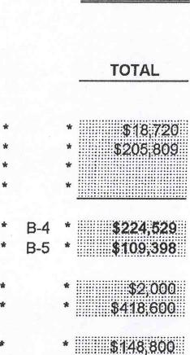
8!
93
- B-4 *
- B-5 *
*
8
*
TOTAL
==== OPERATING APPROPRIATIONS ====
PUBLIC SECT. 8 HOUSING OTHER
TOTAL HOUSING NEW CONS. VOUCHERS PROGRAMS
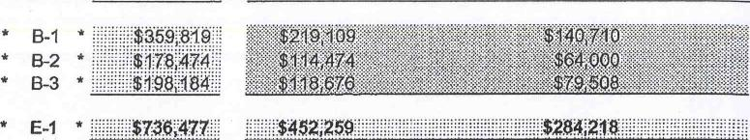
9
$1
- E-1 * ,,,, $7"477.. $45409
- B-1 *
- B-2 *
- B-3 *
Total Other Expenses * B-6 * $4,596,290
TOTAL COST OF PROVIDING
SERVICES• $
- *
- $66,800
- * $21,849
- *
- $9,750

PAGE SS-5

2013
HOUSING AUTHORITY BUDGET
SUPPLEMENTAL SCHEDULES
Housing Authority of the Township of Edison Housing Authority July 1, 2013 to June 30, 2014
BUDGETED YEARS DEBT SERVICE REQUIREMENTS
*
*
--PRINCIPAL PAYMENTS--- | 2013 2012  CROSS PROPOSED CURRENT YEAR'S  REF. BUDGET ADOPTED BUDGET
AUTHORITY NOTES P-1 * 555c:
AUTHORITY BONDS P-2
CAPITAL LEASES P-3

*
INTERGOVERNMENTAL LOANS P-4
OTHER BONDS ORNOTES * P-5

TOTAL PRINCIPAL DEBT PAYMENTS

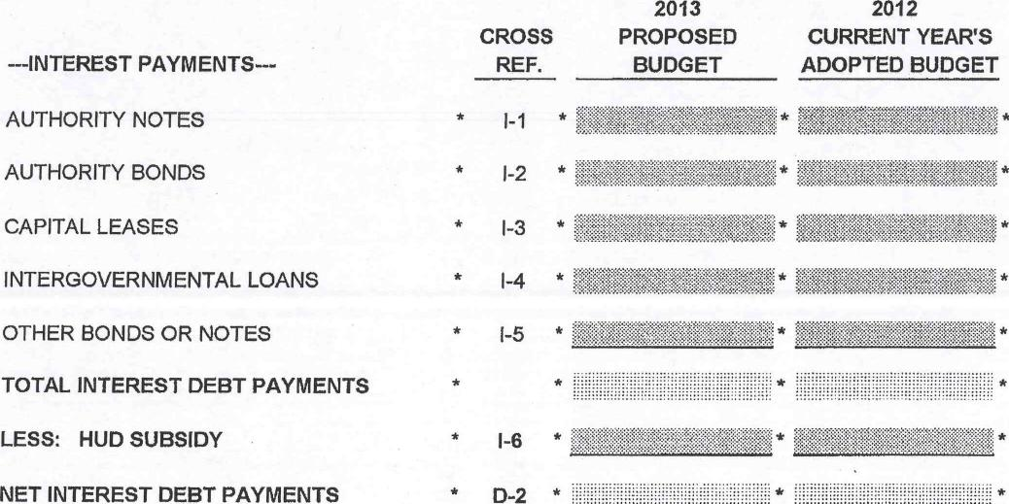
2013
CROSS PROPOSED
REF. BUDGET
*
*
1-6
* D-2 *
2012
CURRENT YEAR'S ADOPTED BUDGET
MY.
---INTEREST PAYMENTS--AUTHORITY NOTES AUTHORITY BONDS CAPITAL LEASES INTERGOVERNMENTAL LOANS OTHER BONDS OR NOTES
TOTAL INTEREST DEBT PAYMENTS LESS: HUD SUBSIDY
NET INTEREST DEBT PAYMENTS
LESS: HUD SUBSIDY * P-6
NET PRINCIPAL DEBT PAYMENTS * D-1
* *
*
- .......... ...

PAGE SS-6

2013
HOUSING AUTHORITY BUDGET
SUPPLEMENTAL SCHEDULES
Housing Authority of the Township of Edison Housing Authority
PRINCIPAL PAYMENTS |  | July 1, 2013 to June 30, 2014  5 YEAR DEBT SERVICE SCHEDULE  YEARS '  2012 2013 2014 2015 2016 |  |  |  |  |  |  |  |  |  |  |  |  |  |  | 2017
--AUTHORITY NOTES--
 | * |  | * |  |  | * |  |  | * |  |  |  |  |  | * |  |  | *
 | * |  |  |  |  | * |  |  | * |  |  |  |  |  | * |  |  | *
 | * |  |  |  |  | * |  |  | * |  |  | * |  |  | * |  |  | *

TOTAL PAYMENTS P-1 * * * *
—AUTHORITY BONDS--
 | * | * |  | * | * | * | *
 | * | * | * | * | * | * | *
 | * | * |  | * | * | * | *

TOTAL PAYMENTS P-2 * * * *
--AUTHORITY CAPITAL LEASES—
 | * | * | * | * | * | * | *
 | * | * | * | * | * | * | *
 | * | * | * | * | * | * | *

TOTAL PAYMENTS P-3 * * * *
—AUTHORITY INTERGOVERNMENTAL LOANS-(0)

TOTAL PAYMENTS P-4
—OTHER BONDS OR NOTES (LIST):--
 | * | * | * | * | * | *
 |  | * | * | * |  | *
 |  | * | * | * |  | *

TOTAL PAYMENTS P-5 * * * *
TOTAL PRIN. DEBT PAYMNTS * Less: HUD Subsidy P-6
NET PRIN. DEBT PAYMTS D-1 *
PAGE SS-7

2013
HOUSING AUTHORITY BUDGET
SUPPLEMENTAL SCHEDULES
Housing Authority of the Township of Edison Housing Authority
INTEREST PAYMENTS |  | July 1, 2013 to June 30, 2014  5 YEAR DEBT SERVICE SCHEDULE  III YEARS  2012 2013 2014 2015 2016 2017
--AUTHORITY NOTES—
 | * |  | * |  |  | * |  |  | * |  |  | * |  |  | * |  |  | *
 | * |  | * |  |  | * |  |  | * |  |  | * |  |  | * |  |  | *
 | * |  | * |  |  | * |  |  | * |  |  | * |  |  | * |  |  | *

TOTAL PAYMENTS 1-1 * * *
—AUTHORITY BONDS--
 | * | * | * | * | * | * | *
 | * | * | * | * | * | * | *
 | * | * | * | * | * | * | *

TOTAL PAYMENTS 1-2 * * * *
—AUTHORITY CAPITAL LEASES—
 | * | * | * | * | * | * | 1k
 |  | * | * | * | * |  | *
 |  | * | * | * | * |  | *

TOTAL PAYMENTS 1-3 * * * * *
--AUTHORITY INTERGOVERNMENTAL LOANS—
 | * | * |  | * | * | * | *
 | * | * | * | * |  | *
 | * | * | * | * | * | * | *
TOTAL PAYMENTS 1-4 * *
—OTHER BONDS OR NOTES (LIST):—
 | * | * | * | * | * | * | *
 | * |  | * |  | * | * | *
 | * |  | * |  | * | * | *

TOTAL PAYMENTS I-5 * * * * * * *
TOTAL INT. DEBT PAYMENTS * Less: HUD Subsidy 1-6
NET INT. DEBT PAYMNTS D-2 *
PAGE SS-8

2013
HOUSING AUTHORITY BUDGET
SUPPLEMENTAL SCHEDULES
Housing Authority of the Township of Edison Housing Authority
July 1, 2013 to June 30, 2014
 | ====RETAINED EARNINGS==== | CROSS  REF. | 2013  PROPOSED  BUDGET
 | BEGINNING BALANCE JULY 1ST, 2012 | * AUDIT | $1,608,337 | *
 | UTILIZED IN CURRENT YEAR'S ADOPTED BUDGET
 | PROPOSED BALANCE AVAILABLE |  | $1,608,337 | *
 | EST. RESULTS OF OPERATION CURRENT BUDGET |  | $2,455 | *
 | ESTIMATED AVAILABLE BALANCE |  | $1,610,792
 | UTILIZED IN PROPOSED YEAR'S CAPITAL BUDGET
 | UTILIZED IN PROPOSED BUDGET
 | TOTAL RETAINED EARNINGS UTILIZED |  |  | *
 | PROPOSED BAL. AFTER UTILIZATION IN BUDGET |  | $1,610,792 | *

 | ====RESTRICTED NET ASSETS==== | CROSS  REF. | 2013  PROPOSED  BUDGET
 | BEGINNING BALANCE JULY 1ST, 2012 | * AUDIT | $475,319 | *
 | UTILIZED IN CURRENT YEARS ADOPTED BUDGET
 | PROPOSED BALANCE AVAILABLE |  | $475,319 | *
 | EST. RESULTS OF OPERATION CURRENT BUDGET
 | ESTIMATED AVAILABLE BALANCE |  | $475,319 | *
 | UTILIZED IN PROPOSED YEAR'S CAPITAL BUDGET
 | UTILIZED IN PROPOSED BUDGET
 | TOTAL RESTRICTED NET ASSETS UTILIZED
 | PROPOSED BAL. AFTER UTILIZATION IN BUDGET |  | $475,319 | *

PAGE SS-9

US DEPARTMENT OF HOUSING AND URBAN DEVELOPMENT Housing Authority of the Township of Edison Housing Authority Fiscal Year 2013

Line Acct.
V_52, Description
July 1, 2013 to June 30, 2014
TOTAL Public
HOUSING | Housing | Section | Housing | Other
AUTHORITY | Mangement | 8 | Voucher | Programs
PROPOSED | Proposed | Proposed | Proposed | Proposed
BUDGET | pludget | Oudoet | Budget | Budget

Homebuyers Monthly Payments For
10 7710 Operating Expense
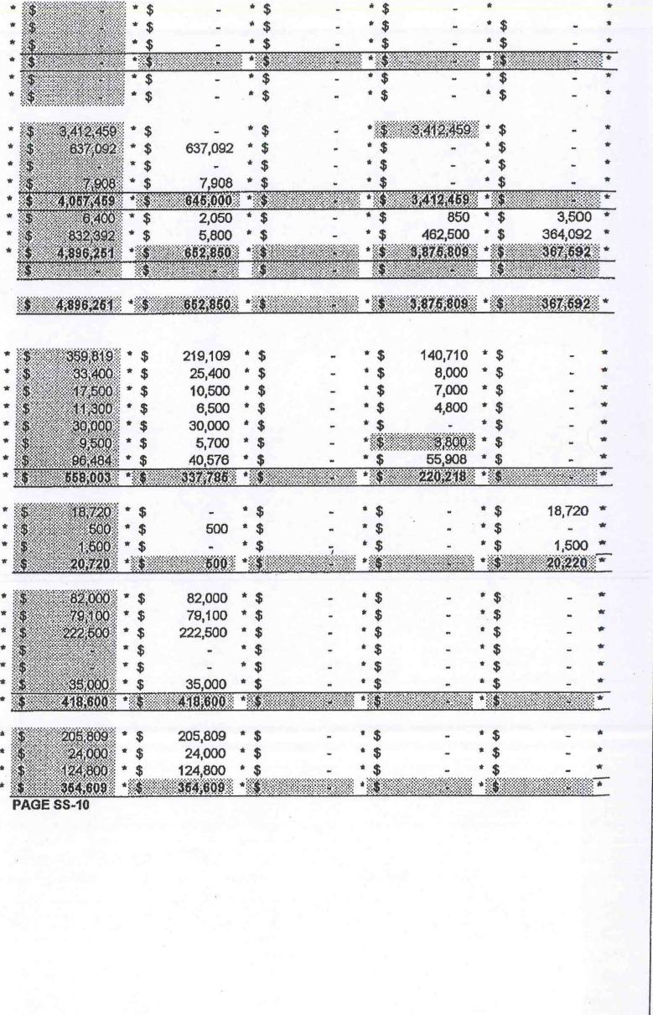
- $
- $
- $
- $
- $
$
- $
- $ *
- $
- $ 82,000 * $
- $ 79,100 * $
- $ 222,500 * $
- *$
- *
205,809 * $ * $ * $ *
24,000 * $ • $ ' $ *
124,800 *$ - *$ - *$ - ª
4j'`IC4X.'⁻⁻1 'ajafgfiNg.4.:::Mil ª AggegNaRg.! *> '•
*gt.ink . , .. .. .. , . .. .....
- • $
"46,:; '.P " •1?. ,MP''''
* $ 2,050 * $ - * $ 850 * $ 3,500 *
5,800 * * $ 482,500 * $ 364,092 *
864 '' — ........ K""N::',' AM.4"8740.88A **'. '.gt.&.i:, ' ffp.'.*
* $ |  | - $
' $ | ' $ | - * $
* $ | - ª $ | - * $
* $ | - • $ | - * $

•
$ 7,908
- *
*hVgi.P. . • 'dr *i3NgE.enl:ge ª 40:g:tatat.: a.i.',M, ª
* $ -
* $ 637,092
$ -
40a4.0m.gg*
- $ - *$ • $ *$ 18,720 *
500 •$ * *
$ *$ *$ - *$ 1,500 a'
*X.MiNg.40.00f-⁻
- $ 140,710 * $
- $ 8,000 * $
- $ 7,000 * $
- $ 4,800 * $
- $ - *
- $ 5,700 * $ *gel:21111A003 * $
• $ 40,576 • $ - $ 55,908 * $
*gtatg.k.0:4:Zale *A.Vggi:MOIVE
219,109 * $ 25,400 $ 10,500 ª $
6,500 $ 30,000 * $
...... „
.. • $ 35,000 * $ - * $ $
- AERVIMPII:,.! *Ptg,.:,:a410.Agin *OMENCRet
PAGE SS-10
20 7712 Earned Home Payments
30 7714 Non-routine Maintenance Res.
40 Total Break Even Amount
50 7716 Excess ( Deficit)
60 7790 Homebuyers Monthly Pay.
Operating Receipts
65 2210 Section 8Noucher Payments
70 3110 Dwelling Rental
80 3120 Excess Utilities
90 3190 Nondwelling Rental
100 Total Rental Income
110 3610 Interest Income
120 3690 Other Income
130 Total Operating Income
136 - Grant Revenue
137 Total Operating Income(Inc. grants)
Operating Expenditures - Administration
140 4110 Administrative Salaries
150 4130 Legal
160 4140 Staff Training
170 4150 Travel
180 4170 Accounting Fees
190 4171 Auditing Fees
200 4190 Other Admin. Expenses
210 Total Administrative Expense
Tenant Services
220 4210 Salaries
230 4220 Recreation, Public. & Other
240 4230 Contract Cost
260 Total Tenant Service Expense
Utilities
260 4310 Water
270 4320 Electricity
280 4330 Gas
290 4340 Fue1011
300 4350 Labor
310 4390 Other
320 Total Utilities Expense
Ordinanry Maintenance & Operations
330 4410 Labor
340 4420 Materials
350 4430 Contract Cost
360 Total Ordinary Maint & Oper. Expense

Line Acct.  No. No. | Description | US DEPARTMENT OF HOUSING AND URBAN DEVELOPMENT  Housing Authority of the Township of Edison Housing Authority  July 1, 2013 to June 30, 2014  OPERATING BUDGET  TOTAL Public  HOUSING Housing Section  AUTHORITY Mangement 8  PROPOSED Proposed Proposed  BUDGET Budget Budget | Housing Voucher Proposed Budget | Other  Programs  Proposed  Budget

Protective Services

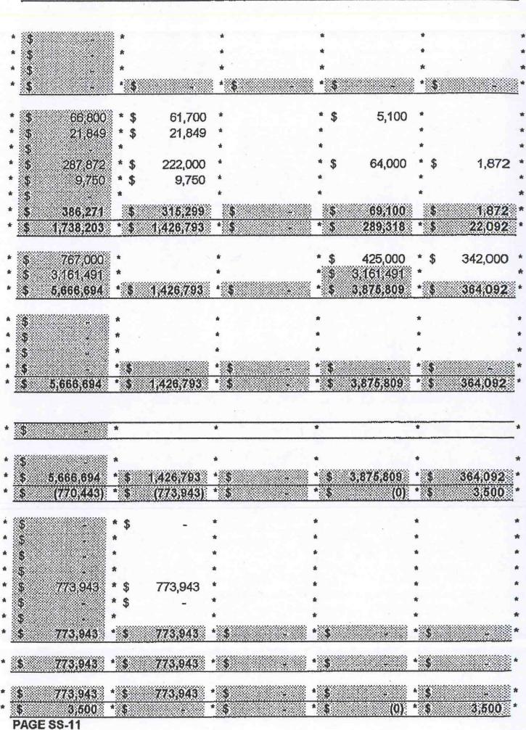
61,700 *
21,849 *
*
*
$ 222,000 *
* $ 9,750 *
q *ENNION0110 tiIRIMOioW*
otnal *M04410.izar trig;10
*4•06410⁻2-*
IVROOSMAK
•
* ;¹0.;REM.a01:0:i. *
773,943
*
*
. „
- ,1-•••• • • • • ••
t:'iN426;79V
6,01z,94) *:4
•
•
* * *
* • • *
"331.1111gge'
* litESE".4402
MEM*
- .C4.0.01*
*
•
•
*
*iftgIVERIK.egi
........... .
- • •
- * *
.titogagsgitggli-
- $ 5,100 •
64,000 $
•

InatittfOgi ...
425,000 * $ 342,000 *
*
"AIDEBRAM. •'
*
•
*-11ONSENSIN.-1
1.$264;426:47M
*MEINEMEN*
1,872 *
*
•
370 4460 Labor
380 4470 Materials
390 4480 Contract Cost
400 Total Protective Services Expense
General Expense
410 4510 Insurance
420 4520 Payment in Lieu of Taxes
430 4530 Terminal Leave Payments
440 4540 Employee Benefits
450 4570 Collection Losses
460 4590 Other General Expense
470 Total General Expense
480 Total Sum of Routine Expenses
Rent for Leased Dwellings
490 4710 Rents to Owners
495 4715 Sect. &Housing Voucher Payments
500 Total Operating Expense
Nonroutine Expenditures
510 4610 Extraordinary Maintenance 520 7520 Replace. of Nonexpendable Equip. 530 7540 Property Betterment & Additions 540 Total Nonroutine Expenditures 550 Total Operating Expenditures
Prior Period Adjustments
560 6010 Prior Period Adjustments Other Expenditures
570 Deficiency
580 Total Operating Expenditures
590 Residual Receipts
HUD Contributions
600 8010 Basic Annual Contribution 610 8011 Prior Year Adjustment
620 Total Basic Annual Contribution
630 8020 Contribution Earned
640 Mandatory
650 Other
660 Other
670 Total Year End Adjustments
680 8020 Total Operating Subsidy - Current
690 Total HUD Contributions
700 Residual Receipts

U.S. DEPARTMENT OF HOUSING AND URBAN DEVELOPMENT SUPPORTING DATA FOR ANNUAL CONTRIBUTION ESTIMATES SECTION 8 ASSISTANCE PAYMENTS
Housing Authority of the Township of Edison Housing Authority
July 1, 2013 to June 30, 2014
 |  |  |  | NO. OF DWELLING UNITS
PROJECT NO. | NJ |  |  | NO. OF UNIT MONTHS
PART I | (a) | (b) | (c) | (d) (e) | (f) | (g)
ESTIMATE | 6 OBR
 | 7 1BR
 | 8 2BR
 | 9 3BR
 | 10 4BR
 | 11
 | 12 |  |  | SUBTOTAL
 | 13
 | 14 |  |  | VACANCY FACTOR

15 TOTAL
PART II UMA'S ADM. FEE | PRODUCT |  |  | ADMIN. FEE
ADMIN. FEE (a) (b) | (c) | (d) |  | (e)
16
17
TOTAL 18
PART III # OF FAMILIES | FEE PER
HARD TO | FAMILY
HOUSE FEE 19 | $75
PART IV
ADMINISTRATIVE |  | PHA | HUD
EXPENSES |  | ESTIMATES | MODIFICATIONS
 |  | (a) | (b)
20 SALARIES
21 EMPL. BEN.
22 LEGAL
23 TRAVEL
24 SUNDRY
25 OFFICE RENT
26 ACCT. FEE
27 TOTAL ADMIN. EXPENSES
NON-EXPENDABLE
EQUIPMENT EXPENSES
28 OFFICE EQUIPMENT
29 OFFICE FURNISHINGS
30 AUTOMOTIVE
31 OTHER
32 TOTAL NON-EXPEN. EQUIP.
GENERAL EXPENSES
33 MAINT. & OPER.
34 INSURANCE
35 SUNDRY
36 TOTAL GENERAL EXPENSE
TOTAL PRELIMINARY EXPENSES
37 SUM OF LINES 27,32,AND 36

PAGE SS-12

U.S. DEPARTMENT OF HOUSING AND URBAN DEVELOPMENT
SECTION 8 ASSISTANCE PAYMENTS
SUPPORTING DATA FOR ANNUAL CONTRIBUTION ESTIMATES Housing Authority of the Township of Edison Housing Authority

NJ
PROJECT NO.
NO. OF DWELLING UNITS NO. OF UNIT MONTHS

11 MAXIMUM ANNUAL CONTRIBUTIONS
12 PRORATA MAXIMUM ANNUAL CONTRIBUTION
13 FISCAL YEAR TOTAL
14 PROJECT ACCOUNT BALANCE
15 TOTAL ANNUAL CONTRIBUTIONS

ACC EXPIR.
DATE
NJ# date
NJ# date
NJ# date
NJ# date
NJ# date
TOTAL ACC

PAGE SS-13

U.S. DEPARTMENT OF HOUSING AND URBAN DEVELOPMENT SECTION 8 ASSISTANCE PAYMENTS
SUPPORTING DATA FOR ANNUAL CONTRIBUTION ESTIMATES Housing Authority of the Township of Edison Housing Authority

NJ
PROJECT NO.
NO. OF DWELLING UNITS NO. OF UNIT MONTHS

16 ESTIMATE OF ANNUAL ASSISTANCE ( line 15)
17 ESTIMATE ONGOING ADMINISTRATIVE FEE (line 18)
18 ESTIMATE HARD TO HOUSE FEE (line 19)
19 ESTIMATED INDEPENDENT PUBLIC ACCOUNTANT COSTS
20 ESTIMATED PRELIMINARY ADMIN. & GEN. EXPENSE (line 27 +36)
21 CARRYOVER OF PRELIMINARY ADMINISTRATIVE EXPENSE
22 ESTIMATED NON-EXPENDABLE EQUIPMENT EXPENSE (line 22)
23 CARRYOVER OF NON-EXPENDABLE EXPENSE
24 TOTAL ANNUAL CONTRIBUTIONS REQUIRED
25 DEFICIT AT END OF CURRENT FISCAL YEAR
26 TOTAL ANNUAL CONTRIBUTIONS REQUIRED
27 ESTIMATED PROJECT ACCOUNT BALANCE (line 15 - line 26)
28 PROVISION FOR PROJECT ACCOUNT REQUESTED (line 27 - line 14) ANNUAL CONTRIBUTIONS APPROVED
29 TOTAL ANNUAL CONTRIBUTIONS APPROVED SOURCE OF TOTAL CONTRIBUTIONS
30a REQUESTED FISCAL YEAR MAXIMUM ANNUAL CONTRIBUTIONS
30b PROJECT ACCOUNT
PAGE SS-14

U.S. DEPARTMENT OF HOUSING AND URBAN DEVELOPMENT SECTION 8 ASSISTANCE PAYMENTS
SUPPORTING DATA FOR ANNUAL CONTRIBUTION ESTIMATES Housing Authority of the Township of Edison Housing Authority
ATTACHMENT I

NJ
PROJECT NO.
NO. OF DWELLING UNITS NO. OF UNIT MONTHS

# UNITS LEASED | AVERAGE EST. # OF UNIT MTHS AVERAGE PAYMENT UNITS LEASED PAYMENT
12 PRELIMINARY ADMIN. & GEN. EXPENSE
13 ESTIMATED HOUSING ASSISTANCE PAYMENTS
14 ESTIMATED ONGOING ADMIN. FEE
15 ESTIMATED HARD TO HOUSE FEE
16 INDEPENDENT PUBLIC ACCT, FEE
17 TOTAL FUNDS REQUIRED
18 PAYMENTS PREVIOUSLY APPROVED
19 ADJUSTMENT TO REQUISITION

20 TOTAL PAYMENT REQUIREMENT
21 EQUAL INSTALLMENTS
22 INSTALLMENTS
 |  |  |  | UNEQUAL INSTALLMENTS
22a | 1 | 2 | 3 |  | 4 | 5 | 6
 | 7 | 8 | 9 |  | 10 | 11 | 12
 | TOTAL

PAGE SS-15

U.S. DEPARTMENT OF HOUSING AND URBAN DEVELOPMENT SUPPORTING DATA FOR ANNUAL CONTRIBUTION ESTIMATES HOUSING VOUCHER ASSISTANCE PAYMENTS
Housing Authority of the Township of Edison Housing Authority
PROJECT NO. NJ NO. OF DWELLING UNITS 375
NO. OF UNIT MONTHS 4,500

11 MAXIMUM ANNUAL CONTRIBUTIONS $3,412,459
12 PRORATA MAXIMUM ANNUAL CONTRIBUTION
13 FISCAL YEAR TOTAL $3,412,459
14 PROJECT ACCOUNT BALANCE
15 TOTAL ANNUAL CONTRIBUTIONS $3,412,459

ACC EXPIR.  DATE  NJ# date  NJ# date  NJ# date  NJ# date  NJ# date | $3,412,459

TOTAL ACC $3,412,459
PAGE SS-17

U.S. DEPARTMENT OF HOUSING AND URBAN DEVELOPMENT SUPPORTING DATA FOR ANNUAL CONTRIBUTION ESTIMATES HOUSING VOUCHER ASSISTANCE PAYMENTS
Housing Authority of the Township of Edison Housing Authority
PROJECT NO. | NJ | NO. OF DWELLING UNITS  NO. OF UNIT MONTHS | 375
 |  |  | 4,500

16 ESTIMATE OF ANNUAL ASSISTANCE ( line 15)
$3,161,491
$250,968
$3,800
17 ESTIMATE ONGOING ADMINISTRATIVE FEE (line 18)
18 ESTIMATE HARD TO HOUSE FEE (line 19)
19 ESTIMATED INDEPENDENT PUBLIC ACCOUNTANT COSTS
20 ESTIMATED PRELIMINARY ADMIN. & GEN. EXPENSE (line 27 +36)
21 CARRYOVER OF PRELIMINARY ADMINISTRATIVE EXPENSE
22 ESTIMATED NON-EXPENDABLE EQUIPMENT EXPENSE (line 22)
23 CARRYOVER OF NON-EXPENDABLE EXPENSE
$3,416,259
$3,416,259
$0
$0
24 TOTAL ANNUAL CONTRIBUTIONS REQUIRED
25 DEFICIT AT END OF CURRENT FISCAL YEAR
26 TOTAL ANNUAL CONTRIBUTIONS REQUIRED
27 ESTIMATED PROJECT ACCOUNT BALANCE (line 15 - line 26)
28 PROVISION FOR PROJECT ACCOUNT REQUESTED (line 27 - line 14) ANNUAL CONTRIBUTIONS APPROVED
29 TOTAL ANNUAL CONTRIBUTIONS APPROVED SOURCE OF TOTAL CONTRIBUTIONS

$3,416,259
$3,416,259
30a REQUESTED FISCAL YEAR MAXIMUM ANNUAL CONTRIBUTIONS
30b PROJECT ACCOUNT
PAGE SS-18

U.S. DEPARTMENT OF HOUSING AND URBAN DEVELOPMENT SUPPORTING DATA FOR ANNUAL CONTRIBUTION ESTIMATES HOUSING VOUCHER ASSISTANCE PAYMENTS
Housing Authority of the Township of Edison Housing Authority
ATTACHMENT I

PROJECT NO. | NJ | NO. OF DWELLING UNITS  NO. OF UNIT MONTHS | 375
 |  |  | 4,500

# UNITS AVERAGE EST. # OF UNIT MTHS AVERAGE LEASED PAYMENT UNITS LEASED PAYMENT

12 PRELIMINARY ADMIN. & GEN. EXPENSE
13 ESTIMATED HOUSING ASSISTANCE PAYMENTS $3,161,491
14 ESTIMATED ONGOING ADMIN. FEE $250,968
15 ESTIMATED HARD TO HOUSE FEE
16 INDEPENDENT PUBLIC ACCT. FEE $3,800

17 TOTAL FUNDS REQUIRED  18 PAYMENTS PREVIOUSLY APPROVED  19 ADJUSTMENT TO REQUISITION | $3,416,259

20 TOTAL PAYMENT REQUIREMENT

$3,416,259
UNEQUAL INSTALLMENTS
3 | 4 | 5 | 6

$284,688
$284,688
$284,688
$284,688

9 | 10 | 11 | 12

21 EQUAL INSTALLMENTS
22 INSTALLMENTS
1 2
$284,688
$284,688
7 8
$284,688
$284,688
$284,688 $284,688 $284,688 $284,688

22a TOTAL $3,416,259

PAGE SS19

